1.Take a list of length 3 containing integers, find out which is larger, first or last one and set all the

elements in the list to be that value. Print the updated list

l=[]

n=3

for i in range(0,n): e=int(input()) l.append(e)

print("original list: ",l) a=max(l)

l=[a]\*3 print("Output: ",l)

Output:

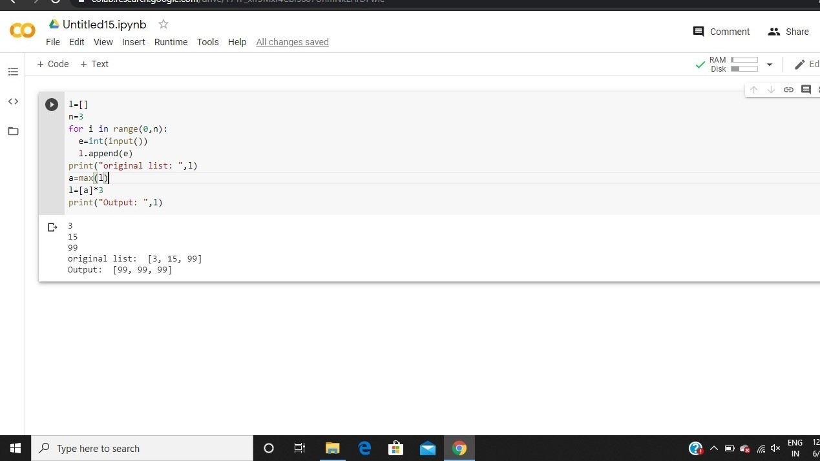

2.Write a python program to generate prime number in an

interval

Input Format  
You will be taking two numbers as an input from stdin one on each line respectively.

Constraints  
1 <= A, B <= 10^4

Output Format  
You need to print the prime numbers one on each line

lower = int(input("Enter lower range: ")) upper = int(input("Enter upper range: ")) for num in range(lower,upper + 1):

if num > 1:

for i in range(2,num): if (num % i) == 0:

break

else:

print(num)

Output:

